**Test Case 01 – CRUD Operation Test In Web Tables Tab [**https://demoqa.com**]**

**[Written By – Anuruddha Dissanayake]**

**Step 01** **-** *Actor Log* [*https://demoqa.com/*](https://demoqa.com/) *Web Si*te

* “Elements Forms“ , “Alerts“, “Frame & Windows“ , “Widgets“ , “Interactions “ , “Book Store Application“ Tabs are Visible

**Step 02 -** *Actor Navigate Elements Tab*

* Click On The Elements Tab
* Actor Navigate Elements Page
* “Text Box” , “Check Box” , “Radio Button” , “Web Tables” , “Buttons” , “Links” , “Broken Links – Images” , “Upload And Download” , “Dynamic Properties ” Tabs Visible Under Element Tab

**Step 03 -** *click elemets tab button*

* “Text Box” , “Check Box” , “Radio Button” , “Web Tables” , “Buttons” , “Links” , “Broken Links – Images” , “Upload And Download” , “Dynamic Properties ” Tabs Not Visible Under Element Tab

**Step 04 *-*** *Click Again Elements Tab Button*

* “Text Box” , “Check Box” , “Radio Button” , “Web Tables” , “Buttons” , “Links” , “Broken Links – Images” , “Upload And Download” , “Dynamic Properties ” Tabs Visible Under Element Tab

**Step 05 -** *Click Web Table Button*

* Web Table Page Will Appear
* Add Button Is Visible And Clickable
* Search Field Is Visible And Clickable
* Search Button Is Visible And Not Clickable

**Step 06 -** *Search The Invalid Data In Search Field*

* No rows found Message Is Displayed

**Step 07 -** *Search The Valid Data In Search Field*

* Search Data Is Displayed
* No rows found Message Is Not Displayed

**Step 08 *-*** *Click Add Button*

* Registration Form Pop Up Will Be Launched
* Close Button Is Visible And Clickable
* Submit Button Is Visible And Clickable
* “First Name” , “Last Name” , “Email” , “Age” , “Salary” , “Department” Fields Are Visible And Clickable In The Registration Form

**Step 09 *-*** *Enter And Select Empty Values For All Fiels*

**Step 10** **-** *click submit button*

* Registration Form Pop Up Will Not Be Closed
* New Record Will Not Be Created
* Error Icon Visible In All Field Right Corner

**Step 11 *-*** *enter and select values*

* First Name For First Name Field – Not Empty Value
* Last Name For Last Name Filed– Not Empty Value
* Email For Email Field – Not Empty Value And Enter Mail Standards ([Example@Mail.Com](mailto:Example@Mail.Com))
* Age For Age Field – Not Empty Value And Not Text Value And Numerical Value
* Salary For Salary Field – Not Empty Value And Not Text Value And Numerical Value
* Department Name For Department Field - Not Empty Value

**Step 12 -** *Click Submit Button*

* Registration Form Pop Up Will Be Closed
* Add New Record Will Be Created And Displayed

**Step 13 *-*** *search the valid data in search field*

* The Search Data Is Displayed
* No rows found Message Is Not Displayed
* Edit Icon And Delete Icon Displayed Infront Of Search Data

**Step 14 -** *Click Edit Icon*

* Registration Form Pop Up Will Be Launched
* Close Button Is Visible And Clickable
* Submit Button Is Visible And Clickable
* Previously Added Data Should Be Visible In Fields

**Step 15 -** *Edit Input Values Empty*

* Clear All Field In Empty Data

**Step 16 *-*** *Click Submit Button*

* Registration Form Pop Up Will Not Be Closed
* New Record Will Not Be Updated
* Error Icon Visible In All Field Right Corner

**Step 17 *-*** *Enter And Select Values*

* First Name For First Name Field – Not Empty Value
* Last Name For Last Name Filed– Not Empty Value
* Email For Email Field – Not Empty Value And Enter Mail Standards ([Example@Mail.Com](mailto:Example@Mail.Com))
* Age For Age Field – Not Empty Value And Not Text Value And Numerical Value
* Salary For Salary Field – Not Empty Value And Not Text Value And Numerical Value
* Department Name For Department Fieldn - Not Empty Value

**Step 18 -** *click submit button*

* Registration Form Pop Up Will Be Closed
* Record Will Be Updated And Displayed New Values

**Step 19 -** *Search The Valid Data In Search Field*

* The Search Data Is Displayed
* No rows found Message Is Not Displayed
* Edit Icon And Delete Icon Displayed Infront Of Search Data

**Step 20 -** *Click The Delete Icon*

* Search Data Row Will Be Deleted
* No rows found Message Is Displayed
* Search Data Will Not Be Visible

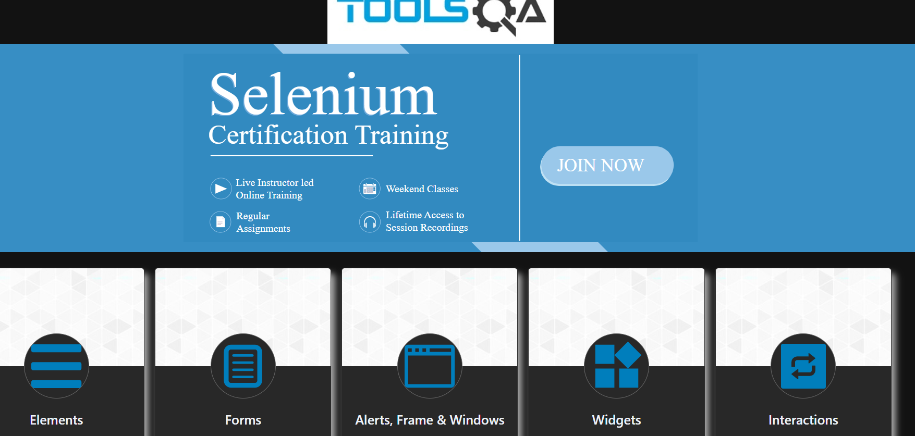**Step 21-** *Close The Browser For Quit*